

**School of Engineering and Technology**

**Emerging Web Technologies**

*(Practical File)*

**15BCS-0WT32T**

***Submitted To:***

***Submitted By:***

Name: Tanya Yadav

Roll Number: 170BTCCSE061

Branch: Computer Science and Engg.

Year/Sem: 3rd Year – 6th Semester

Faculty: Ms.Vijaya Lakshmi Singh

**INDEX**

|  |  |  |  |
| --- | --- | --- | --- |
| **S.No.** | **Program Title** | **Date** | **Signature** |
| **1** | Experiment 1 | 29/01/20 |  |
| **2** | Experiment 2 | 05/02/20 |  |
| **3** | Experiment 3 | 12/02/20 |  |
| **4** | Experiment 4 | 26/02/20 |  |
| **5** | Experiment 5 | 04/03/20 |  |
| **6** |  |  |  |
| **7** |  |  |  |
| **8** |  |  |  |
| **9** |  |  |  |
| **10** |  |  |  |

**EXPERIMENT 1**

Q1-Write the HTML page to produce the following output:

**Name Chemical Formula**

1. Water H2O
2. *Carbon Dioxide* CO2
3. **Ethanol** C2H5OH

Input:-

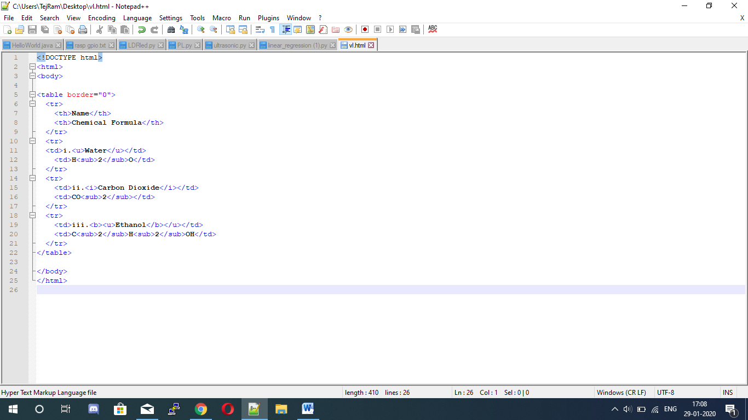

Output:-

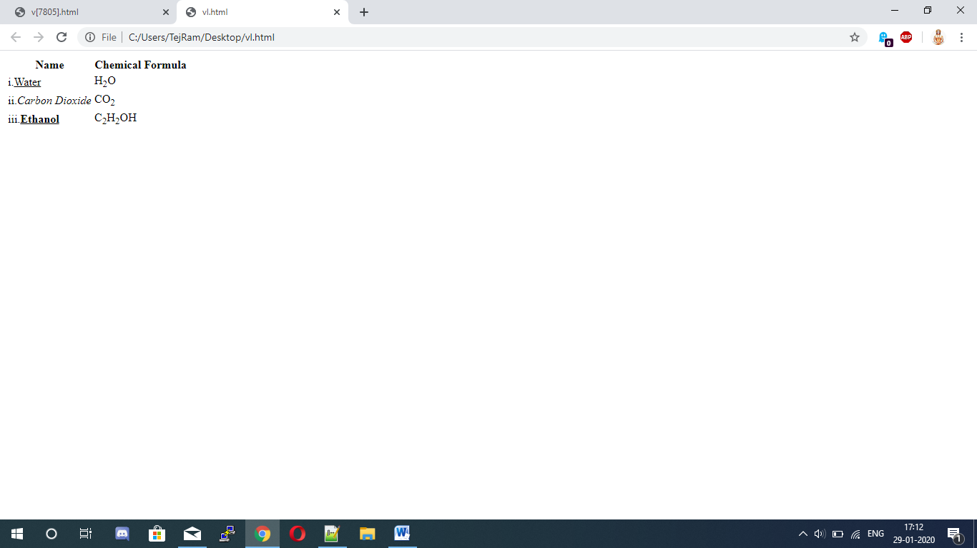

Q2-Create the following list in HTML.

* **School of Engineering**

1. Deptt of Computer Science
2. Dr. P.K. Ghosh
3. Dr. Sumit Kumar
4. Dr. N.K. Mehta
5. Deptt of Electronics
6. Dr. P.K. Gupta
7. Dr. M.K. Sindhu
8. Deptt of Electricals
9. Dr. A. Kumar
10. Mr. V.K. Sharma

* **School of Management**

1. Dr. Ranveer Singh
2. Dr. Om Prakash
3. Dr. C.K. Katyal

* **School of Applied Science**

1. **Deptt of Chemistry**

* Dr. P.N. Trivedi
* Mr. D.K. Singh

1. **Deptt of Physics**

* Dr. L.P. Pangti
* Mr. D.K. Arora

Input:-

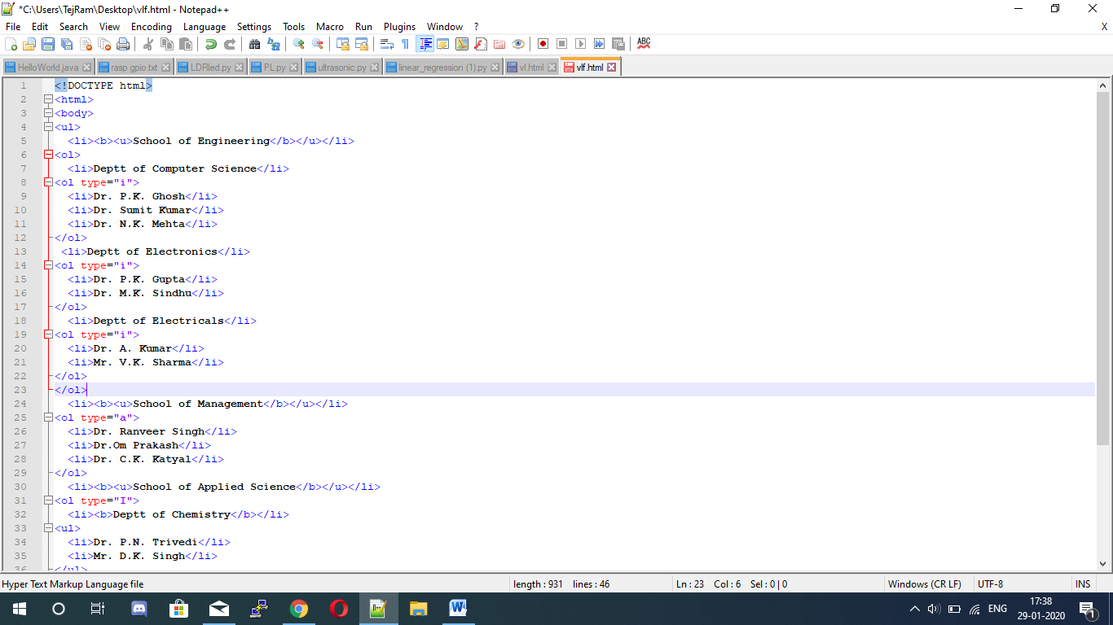

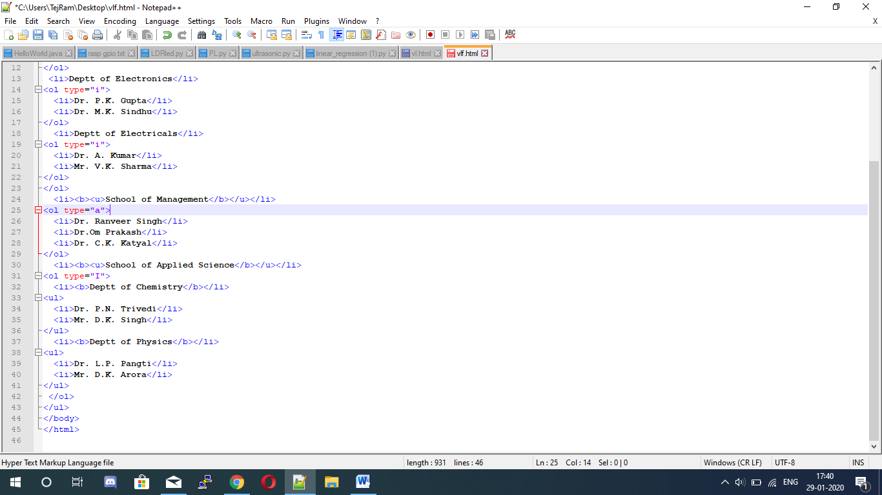

Output:-

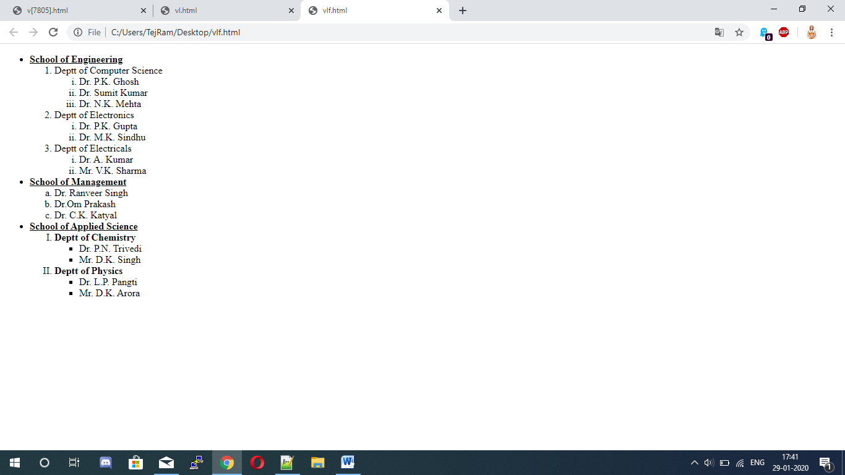

Q3-Create a web page of your college with following specifications:-

Place your college name at the top of the page in large text followed by address in smaller size add names of courses offered each in a different colour, style and typeface.

Add Scrolling text with a message of your choice add college image at the bottom.

Input:-

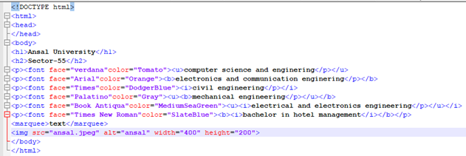

Output:-

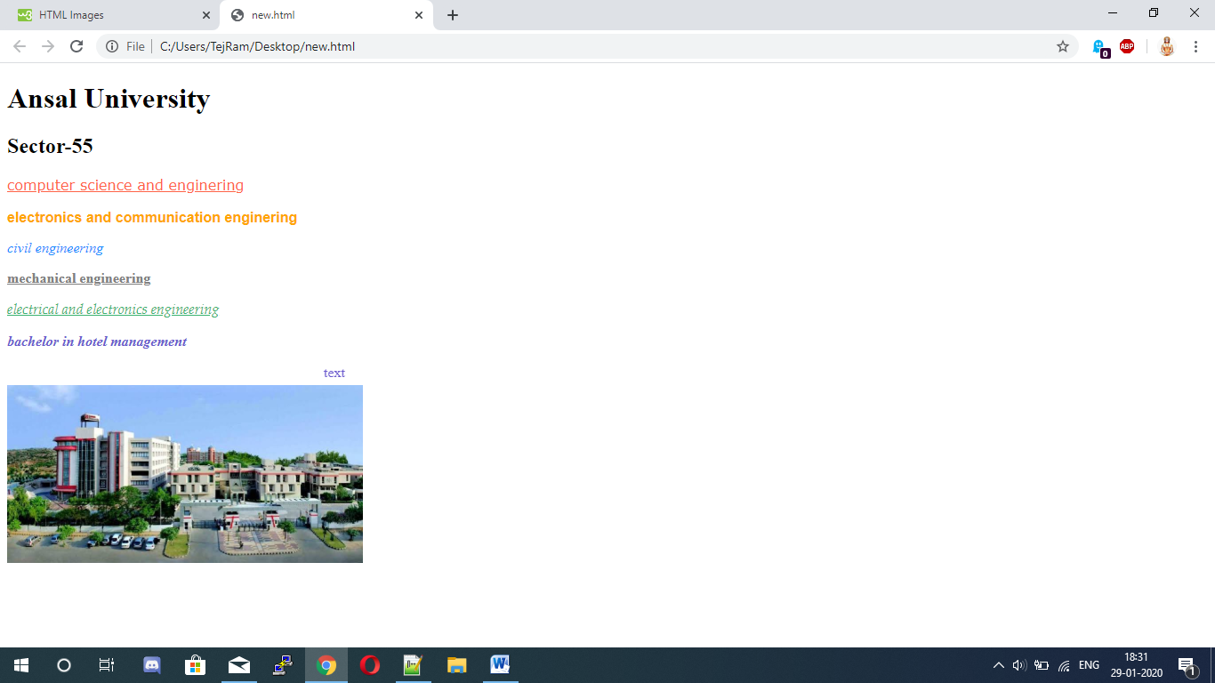

Q4- Create an html page with red background with a message “warning” in large size blinking. Add scrolling text “read the message” below it.

Input:-

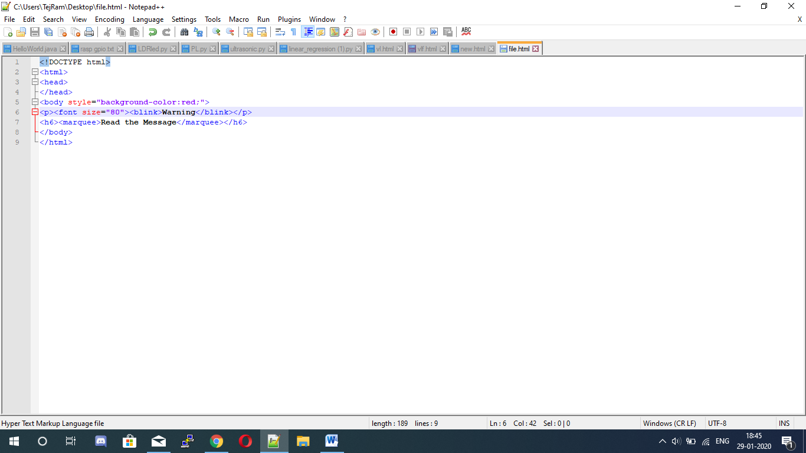

Output:-

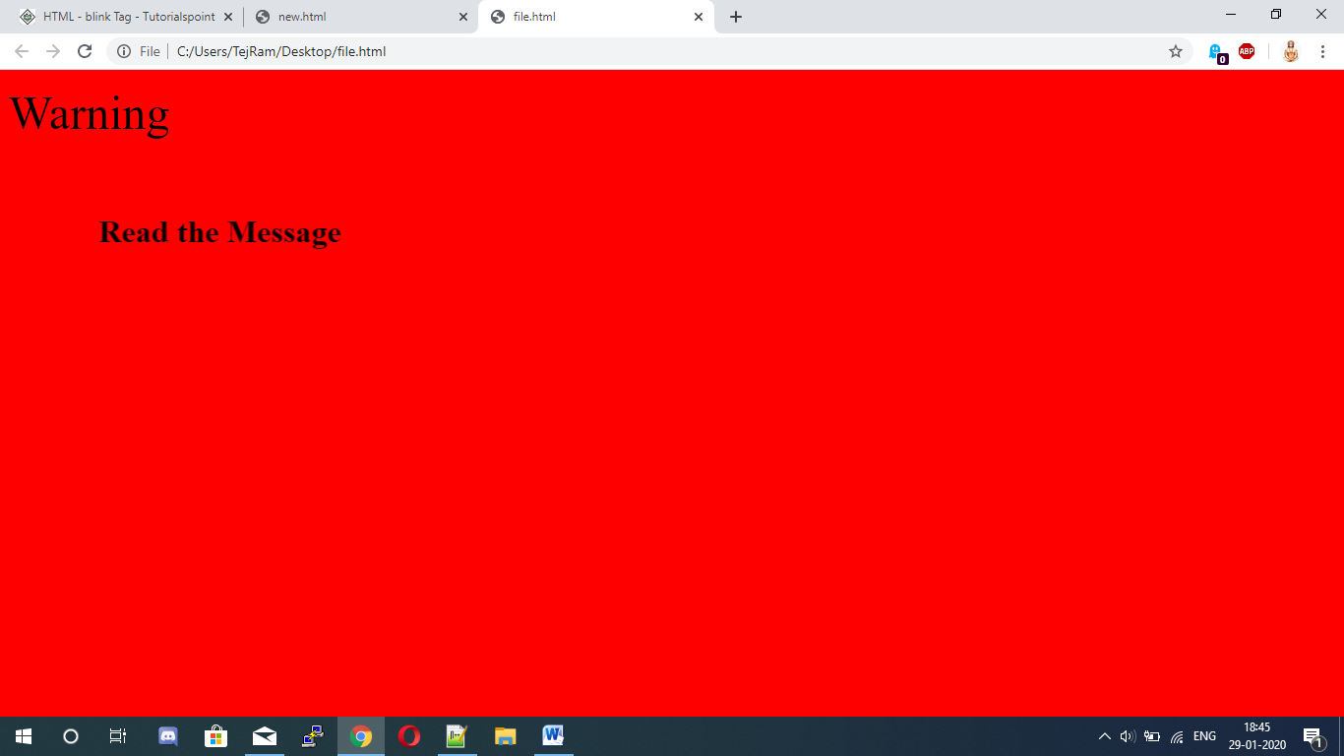

Q5- Create an html page with 7 separate lines in different colours. State colour of each line in its text.

Input:-

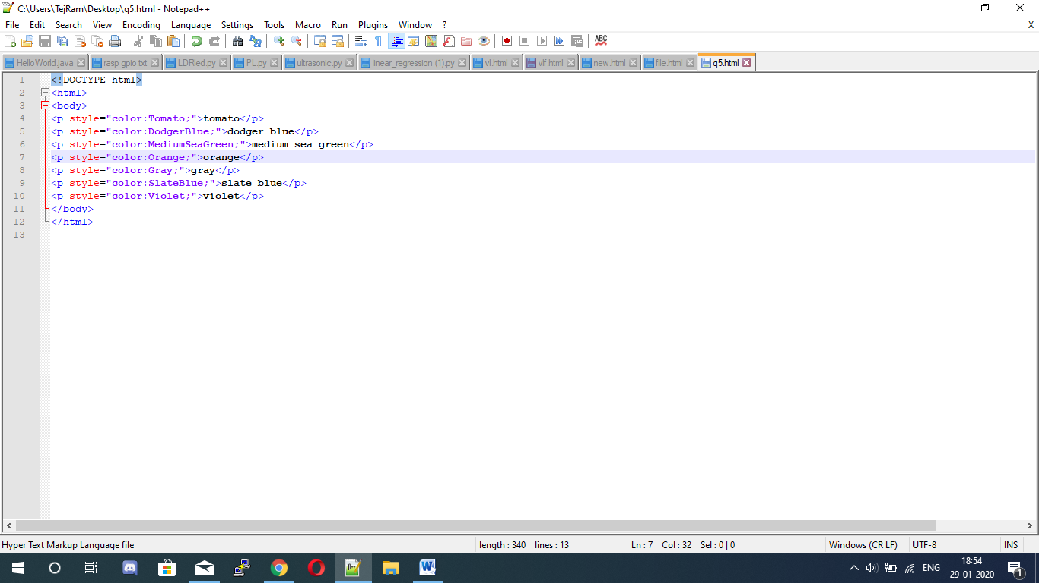

Output:-

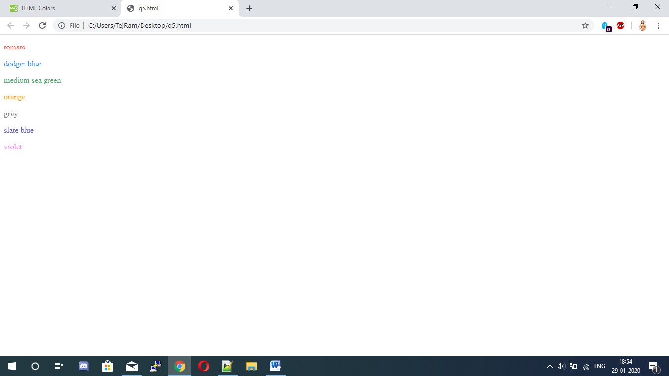

Q6- Create an html page with all the different text styles (bold, italic, underline) and its combinations on separate lines. State style of each line in its text.

Input:-

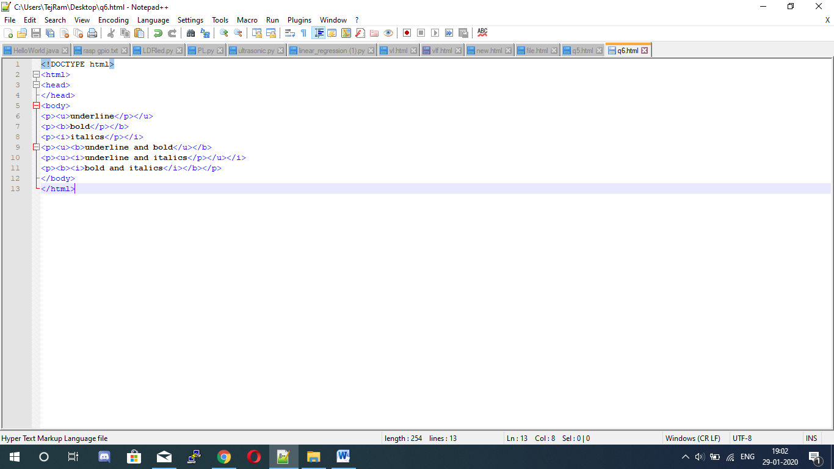

Output:-

